MATHEMATICS APPLICATIONS

MAWA Semester 2 (Units 3 & 4)
Examination 2017

Calculator-Assumed

Marking Key

Section Two: Calculator-assumed (100 Marks)

Question 7 (a)
Solution

Suburb | Houses | Units | Blocks
EB | 54 | 14 | 8
WB | 121 | 15 | 43
Totals | 175 | 29 | 51

Marking key/mathematical behaviours | Marks
- enters given data into correct cells of the table | 1

Question 7 (b)
Solution

Suburb | Houses | Units | Blocks
EB | 31% | 48% | 16%
WB | 69% | 52% | 84%
Totals | 100% | 100% | 100%

Marking key/mathematical behaviours | Marks
- provides total percentages for each column  - determines percentages for two types of properties  - determines percentages for a third type of property | 1  1  1

Question 7 (c)
Solution

There does not appear to be any association between the suburb and the units sold.
The proportions of houses and blocks appear to be linked to the suburb and much higher in West Busselton than in East Bunbury
Marking key/mathematical behaviours | Marks
- identifies association of suburb with each type of property  - describes associations clearly  - describes association in terms of proportions | 1  1  1

Question 8 (a)
Solution

n | 0 | 1 | 2
Value after n months ($) | $2400 | $2304 | $2211.84

Marking key/mathematical behaviours | Marks
- enters value for 0 and 1 month  - enters value after 2 months | 1  1

Question 8 (b)
Solution

4% per month
Marking key/mathematical behaviours | Marks
- identifies rate | 1

Question 8 (c)
Solution

${ V}_{n}$ = 2400${(0.96)}^{n}$
Marking key/mathematical behaviours | Marks
- identifies starting term and rate  - uses correct format for the rule | 1  1

Question 8 (d)
Solution

2400 x 0.96¹² = $1470.50
Marking key/mathematical behaviours | Marks
- identifies rate | 1

Question 8 (e)
Solution

% decrease = (2400-1470.50)/2400 x 100 = 38.73%
Marking key/mathematical behaviours | Marks
- identifies value of decrease  - determines percentage decrease | 1  1

Question 8 (f)
Solution

After 39 months. At the end of September 2020
Marking key/mathematical behaviours | Marks
- determines duration  - determines end of time interval | 1  1

Question 9 (a)
Solution

CEGH 50
CEJGH 20
CJGH 10
CJH 90
CLJH 20
CLNH 40
Total number of trains is 230
Marking key/mathematical behaviours | Marks
- Determines 2 paths and their respective number of trains  - Determines a further 2 paths and their respective number of trains  - Determines a further 2 paths and their respective number of trains  - Determines maximum number of trains | 1  1  1  1

Question 9 (b)
Solution

190 trains
Marking key/mathematical behaviours | Marks
- determines maximum number possible through J | 1

Question 9 (c)
Solution
LN by 10, EJ by 10 and GH by 70
EG by 10 and GH by 60 [Other solutions possible]
Marking key/mathematical behaviours | Marks
- identifies edges with greater capacity  - determines size of extra capacity | 1  1

Question 10 (a)
Solution

Increasing (or positive) trend

Marking key/mathematical behaviours | Marks
- identifies trend from graph | 1

Question 10 (b)
Solution

Every fourth value is the highest of the four in that year.
Marking key/mathematical behaviours | Marks
- describes seasonality | 1

Question 10 (c)
Solution

Circles the point at (20, 45)
Marking key/mathematical behaviours | Marks
- identifies the outlier | 1

Question 10 (d)
Solution

(22 + 21 + 16 + 45) ÷ 4 = 26
Marking key/mathematical behaviours | Marks
- determines mean | 1

Question 10 (e)
Solution

170% which indicates the number is well above the average for the 4 seasons in that year
Marking key/mathematical behaviours | Marks
- determines percentage of seasonal mean  - describes significance of seasonal mean | 1  1

Question 10 (f)
Solution

(59% + 103% + 52% + 81% + 72%) ÷ 5 = 73.4%
Marking key/mathematical behaviours | Marks
- calculates seasonal index | 1

Question 10 (g)
Solution

11 ÷ 52% = 21
Marking key/mathematical behaviours | Marks
- applies rule to deseasonalise  - uses appropriate rounding | 1  1

Question 10 (h)
Solution

Car thefts will continue to rise.
Need to know that the number of cars parked at the airport will not decrease significantly
Marking key/mathematical behaviours | Marks
- describes prediction based on data provided  - identifies further information needed to support the prediction | 1  1

Question 11 (a)
Solution
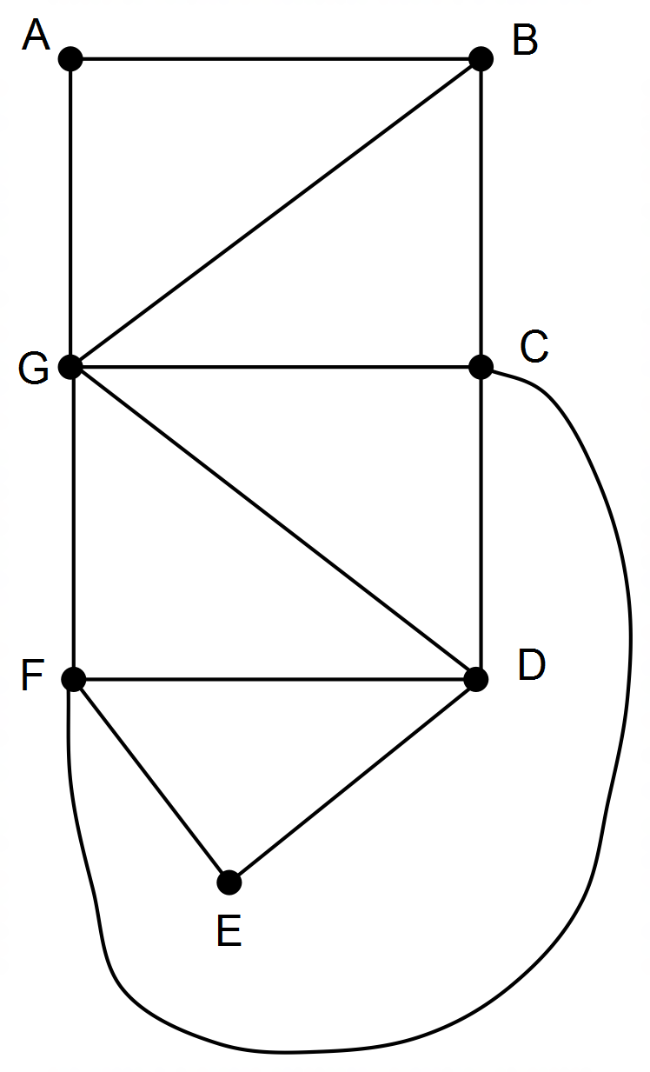

Marking key/mathematical behaviours | Marks
- identifies graph in planar form | 1

Question11 (b)
Solution

B and G
Marking key/mathematical behaviours | Marks
- identifies odd vertices | 1

Question 11 (c)
Solution

BCFEDFGDCGABG
Marking key/mathematical behaviours | Marks
- starts and finishes at the odd vertices  - all sequence correct with no more than one leg missing  - all legs represented | 1  1  1

Question 11 (d)
Solution

Graph is connected
Starts and ends at different nodes
All edges crossed once only
Marking key/mathematical behaviours | Marks
- describes two features of semi-eulerian graphs | 2

Question 11 (e)
Solution

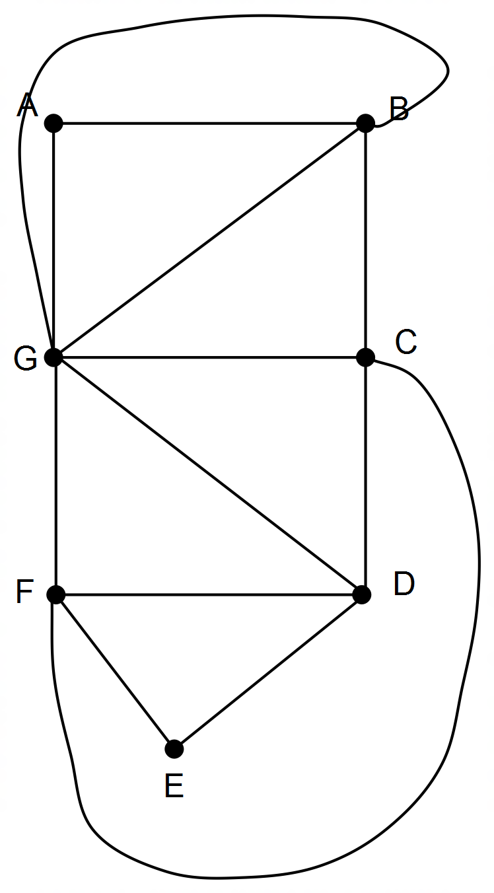

Marking key/mathematical behaviours | Marks
- identifies an Eulerian graphs | 1

Question 11 (f)
Solution
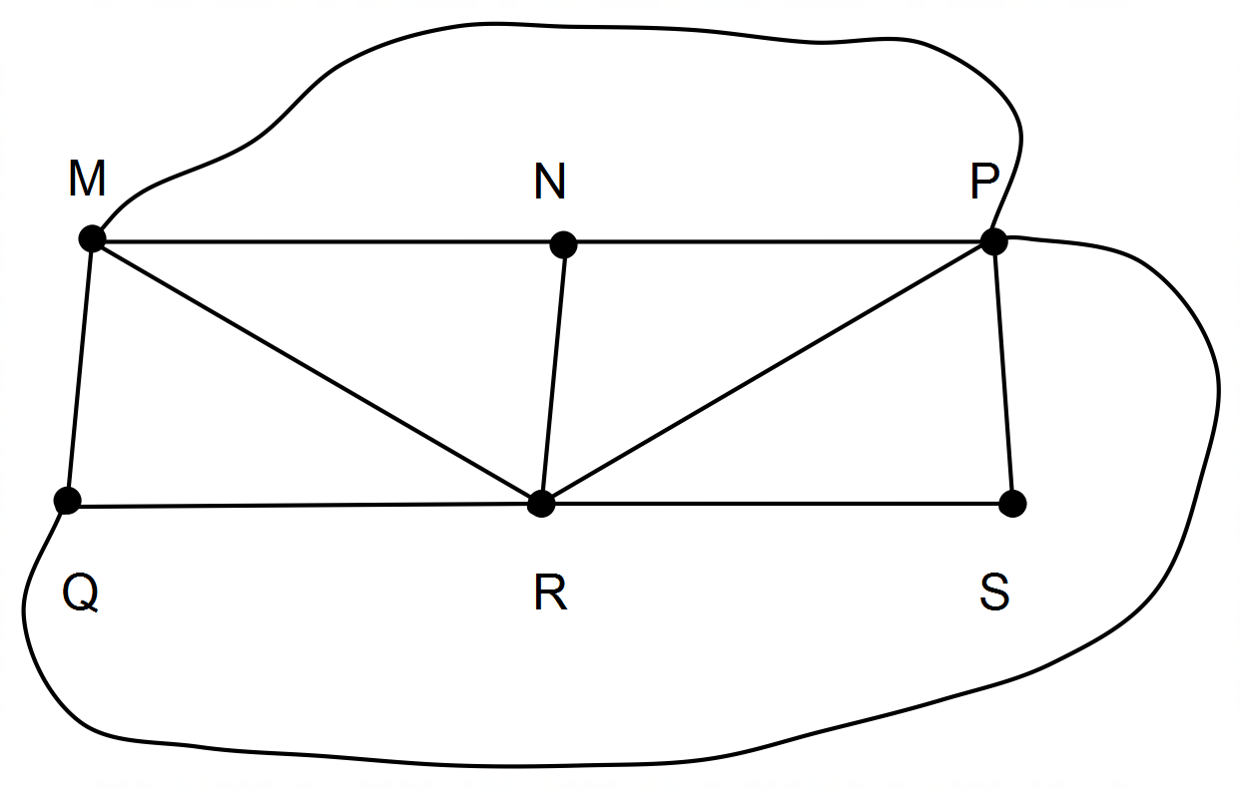

Marking key/mathematical behaviours | Marks
- graph has 11 edges and 6 nodes (two of which are odd)  - graph has 7 faces  - graph is semi-eulerian | 1  1  1

Question 12 (a)
Solution

0.75% or 0.0075
Marking key/mathematical behaviours | Marks
- calculates monthly interest rate | 1

Question 12 (b)
Solution

B_{n+1} = 1.0075B_{n} + 200, B₀ = 1000
Marking key/mathematical behaviours | Marks
- uses equation to determine deseasonal value  - makes seasonal adjustment | 1  1

Question 12 (c)
Solution

$1627.18, $12.20, $200.00, $1839.38
Marking key/mathematical behaviours | Marks
- enters values given in question  - calculates interest  - determines account balance at end of month  - Rounds all values to nearest cent | 1  1  1  1

Question 12 (d)
Solution

After 18 months. / By the end of the 19th month.
Marking key/mathematical behaviours | Marks
- Indicates time total reached | 1

Question 12 (e)
Solution

$5220.38 – (1000 + 19 x 200)= $420.38
Marking key/mathematical behaviours | Marks
- determines total deposit  - calculates total interest | 1  1

Question 12 (f)
Solution

Yes, No, Yes, Yes
Marking key/mathematical behaviours | Marks
- identifies influence of each of 4 factors on the investment growth | 4

Question 13 (a)
Solution

ZQRE 31 hours
Marking key/mathematical behaviours | Marks
- identifies critical path  - determines minim time | 1  1

Question 13 (b)
Solution

After 21 hours
Marking key/mathematical behaviours | Marks
- identifies earliest start time | 1

Question 13 (c)
Solution

8 hours from commencement
Marking key/mathematical behaviours | Marks
- identifies latest start time | 1

Question 13 (d)
Solution

9 hours
Marking key/mathematical behaviours | Marks
- determines float time | 1

Question 13 (e)
Solution

Critical path in unchanged and minimum completion time reaches 34 hours
Marking key/mathematical behaviours | Marks
- determines effect of change on critical path  - determines effect of change on minimum completion time | 1  1

Question 14 (a)
Solution

$10 956.90
Marking key/mathematical behaviours | Marks
- calculates future value | 1

Question 14 (b)
Solution

= (1+0.0305/12)¹² – 1 = 0.03093 So 3.09%
Marking key/mathematical behaviours | Marks
- substitutes into formula  - calculates effective rate of interest  - gives interest as a percentage correct to 2 decimal places | 1  1  1

Question 14 (c)
Solution

Yes – the interest rate is higher than the 3.09% effective rate of interest
Marking key/mathematical behaviours | Marks
- concludes in the affirmative  - compares 3.10% to the effective rate of interest | 1  1

Question 14 (d)
Solution

With a higher annual interest rate
With interest compounded more frequently
Marking key/mathematical behaviours | Marks
- identifies two different ways to increase the value of the investment | 2

Question 15 (a)

Solution

Marking key/mathematical behaviours | Marks
- all diagonal entries are 0  - all 0s correct  - all 1s correct | 1  1  1

Question 15 (b)
Solution

Person A
The total of the numbers in their column is the highest
Marking key/mathematical behaviours | Marks
- interprets adjacency matrix  - describes values in adjacency matrix | 1  1

Question 15 (c)
Solution

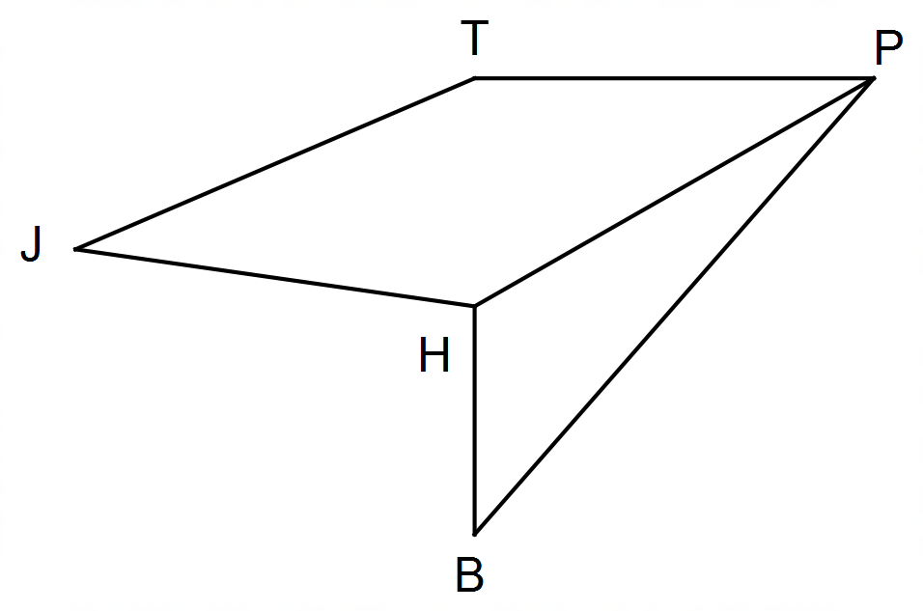(i)
$\left[\begin{matrix}0 & 4 & 1 & 5 & 2 \\ 4 & 0 & 5 & 1 & 2 \\ 1 & 5 & 2 & 6 & 4 \\ 5 & 1 & 6 & 2 & 4 \\ 2 & 2 & 4 & 4 & 2\end{matrix}\right]$

(ii) There are 2. JHPB and JTPB
Marking key/mathematical behaviours | Marks
- determines cube of matrix  - determines number of three-stage communications  - names each three-stage communication | 1  1  1

Question 16 (a)
Solution

DADEC = -0.142 X 25 + 13.4 = 9.85
103% of 9.85 = 10.1
Marking key/mathematical behaviours | Marks
- substitutes into equation  - determines deseasonalised value  - adjusts using seasonal index | 1  1  1

Question 16 (b)
Solution

Not very reliable as the numbers used are averages / the June 2014 figure could be atypical of the June average and this could make the seasonal average lower than the long term trend for that seasonal average.
Marking key/mathematical behaviours | Marks
- identifies prediction not very reliable  - explains lack of reliability | 1  1

Question 16 (c)
Solution

Deseasonalised data (DADEC) = -0.219t + 14.8
Marking key/mathematical behaviours | Marks
- determines gradient and y-intercept  - expresses relationship in linear form with correct variables | 1  1

Question 16 (d)
Solution

The rate for the last two years shows an increasing downward trend (-0.219 compared to -0.142). This indicates that the trend for the first two years was less negative and maybe even positive. The gradient of the line for that period would have been greater than -0.142.
Marking key/mathematical behaviours | Marks
- describes the trend for the first two years  - justifies the description of the change | 1  1

Question 17 (a)
Solution

450 000 x 0.95 x 1.085 = $463 837. 50
Marking key/mathematical behaviours | Marks
- states an expression to calculate value using percentage decrease  - determines value of investment | 1  1

Question 17 (b)
Solution
$1471.15

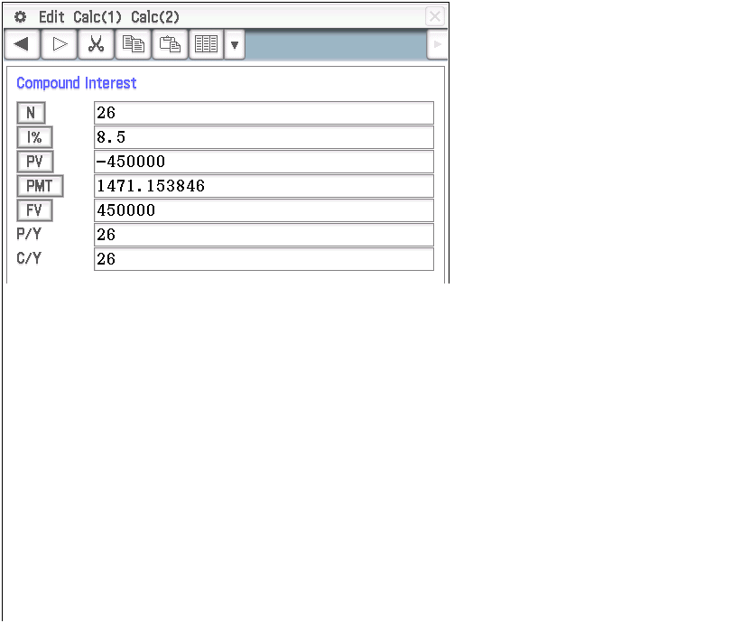
Marking key/mathematical behaviours | Marks
- identifies all correct variables  - determines withdrawal amount | 1  1

Question 17 (c)
Solution

After the first 5 years, the superannuation is worth $331 856.95
[N=5, I% = 6.5, PV= 450000, PMT=50000,FV=?]
After the next 5 years, the superannuation is worth $198 458.94
[N=5, I% = 6.5, PV= =$331 856.95400000, PMT=$45 000,FV=?]
He can only take a salary of $40000 for the next 6 years after that (16 years all together)
[N=?, I%=6.5, PV = 198 458.94, FV=0]
Marking key/mathematical behaviours | Marks
- determines value after 5 years  - determines value after 10 years  - determines duration of the investment | 1  1  1

